CITY OF EARLHAM, IOWA

URBAN REVITALIZATION PLAN

for the

EARLHAM URBAN REVITALIZATION AREA

2018

LOCAL GOVERNMENT PROFESSIONAL SERVICES, INC.

DBA SIMMERING-CORY

INTRODUCTION
The Urban Revitalization Act, Chapter 404 of the Code of Iowa, is intended to encourage development, redevelopment, and revitalization within a designated area of a city by authorizing property tax development incentives to the private sector. Qualified real estate within a designated area may be eligible to receive a total or partial exemption from property taxes on improvements for a specified number of years, with the goal of providing communities with a long-term increase or stabilization in the local tax base by encouraging rehabilitation and additions or new construction which might not otherwise occur.

The City Council of the City of Earlham (“City”) has determined that there is a need for incentives to stimulate new construction of and improvements to both residential and multi-residential properties. Earlham is located in central Iowa just six miles south of Interstate 80. The City’s proximity to I-80, the Des Moines Metro area, and the nearby towns of Adel, Waukee, Clive, West Des Moines, and Urbandale makes it a desirable place for residents to live. City officials feel that increasing the availability of housing opportunities may promote residential growth throughout the City. To promote residential opportunities, it is important that the City provide incentives to spur this growth. This may improve livability of the community and assist the City in becoming a more desirable place to live and work.

Section 404.1(2) of the Code of Iowa provides that a City Council may designate an area of the City as a revitalization area, if that area meets the following definition:

“An area which by reason of the presence of a substantial number of deteriorated or deteriorating structures, predominance of defective or inadequate street layout, incompatible land use relationships, faulty lot layout in relation to size, adequacy, accessibility or usefulness, unsanitary or unsafe conditions, deterioration of site or other improvements, diversity of ownership, tax or special assessment delinquency exceeding the actual value of the land, defective or unusual conditions of title, or the existence of conditions which endanger life or property by fire and other causes, or a combination of such factors, substantially impairs or arrests the sound growth of a municipality, retards the provision of housing accommodations or constitutes an economic or social liability and is a menace to the public health, safety, or welfare in its present condition and use.”

With the adoption of this Earlham Urban Revitalization Plan (“Plan”), the Earlham City Council (“City Council”) is designating the Earlham Urban Revitalization Area (“Area” or “Revitalization Area”) as being a qualified revitalization area under Section 404.1(2) of the Code of Iowa.

The City finds that the rehabilitation, conservation, redevelopment, economic development, or a combination thereof, of the Area, is necessary in the interest of the public health, safety, and welfare of the residents of the City and that the Revitalization Area substantially meets criteria established in Section 404.1 of the Code of Iowa as being a qualified revitalization area.

The City has no other urban revitalization plans in effect at this time.
Section 404.2 of the Code of Iowa requires that a city prepare a plan to govern activities within the proposed revitalization area. The balance of this document is intended to set out the elements of the plan as mandated by State law.
DESCRIPTION OF THE AREA AND MAP
The Revitalization Area shall be known as the Earlham Urban Revitalization Area. The legal description of real property to be included within the Revitalization Area is as follows:

All real property contained within the incorporated limits of the City of Earlham, Madison County, State of Iowa, as of January 1, 2018. Any land annexed into the City in the future shall be automatically included in the Revitalization Area as of the effective date of the annexation.

A map illustrating the real property to be included within the Revitalization Area as of January 1, 2018, is attached hereto as Exhibit “A.”
DESIGNATION CRITERIA
In accordance with Section 404.1(2) of the Code of Iowa, the City Council has designated the Revitalization Area as a blighted area, based on the finding of the following conditions in the Area:

- A substantial number of deteriorated and deteriorating structures,
- Unsanitary or unsafe conditions,
- Defective and inadequate street layout, and
- The existence of conditions which endanger life or property, and which substantially impairs the sound growth of the City, retards the provision of housing accommodations and constitutes an economic and social liability and is a menace to the public health, safety or welfare in its present condition and use.

Existing conditions in the Area, as surveyed in July 2016 as part of a blight assessment resulting in a final report issued January 2018, are consistent with the criteria necessary to verify a finding of blight pursuant to Section 404.1(2) of the Code of Iowa.
OBJECTIVES
This Plan is prepared in conformance with Section 404.1 and Section 404.2 of the Code of Iowa for the purpose of providing incentives and outlining procedures to enhance the potential for residential and multi-residential development and redevelopment in the City. The primary objectives of this Plan are as follows:

- Encourage rehabilitation of additions to and new construction of residential and multi-residential properties through abatement of taxes on the value of the improvements.

- Improve economic conditions in the Area through blight remediation and by taking steps to enhance the general attractiveness of the Revitalization Area.

- Revitalize the Area and remediate blight through the promotion of new residential construction on vacant land, rehabilitation of existing residential property, stabilizing and increasing the tax base, and providing overall aesthetic improvement.

It may be that some of the improvements will be on land that is assessed as agricultural land. The City will present justification at the public hearing, held pursuant to Section 404.2, for the revitalization of land assessed as agricultural property by means of new construction. Such justification will include information about the City’s need for additional housing. Such justification shall demonstrate, in addition to the other requirements of Chapter 404 and Section 419.17 of the Code of Iowa, that the improvements on land assessed as agricultural land will utilize the minimum amount of agricultural land necessary to accomplish the revitalization of the residential property within the Revitalization Area. The City finds that the amount of land assessed as agricultural land in the City, when that amount is compared to the amount of agricultural land in the County, is minimal and use of such land is necessary to accomplish the objectives of this Plan, as set out above.
PRESENT ZONING CLASSIFICATIONS
Zoning classifications in the Revitalization Area include:

Agricultural (A)
Residence (R)
Commercial (C)
Industrial (M)
EXISTING LAND USE
Existing land use categories are the same as the zoning classifications described above.
PROPOSED LAND USE
The Revitalization Area is proposed for new residential and multi-residential development as well as rehabilitation of and additions to existing homes. These uses are in compliance with the City’s Zoning Ordinance.
PROPOSALS FOR EXPANDING CITY SERVICES
No extensions or upgrades to existing municipal services or infrastructure are currently planned. The City proposes that, as development warrants and it becomes financially feasible, the provision of municipal services to the Revitalization Area will be expanded and improved, as needed, to meet the demands of new residential and multi-residential development.
ELIGIBLE IMPROVEMENTS
Qualified real estate under this Plan includes all applicable property assessed as residential or multi-residential which is located in the designated Area and to which eligible improvements have been added during the time the Area was so designated. Eligible improvements, as used in this Plan, include rehabilitation of and additions to existing structures and new construction on vacant land or on land with existing structures located within the Area, if the actual value added by improvement satisfies the percent increase requirements in this Plan.

Actual value added by improvements, as used in this Plan, means the actual value added by eligible improvements as of the first year for which the exemption was received according to the tax assessment valuation determined by the Madison County Assessor. In order to be eligible for tax abatement, the increase in the actual value of the structure due to the improvements, must be at least ten-percent (10%). If more than one structure is located on the property, the ten-percent (10%) increase applies only to the structure or structures to which the improvements were made. If no structures were located on the property prior to the improvements, any percent increase in actual value added by improvements may qualify. However, increases in taxes because of the increased assessed value for land are not eligible for abatement.

All improvements, in order to be considered eligible, must be completed in conformance with all applicable regulations of the City. No abatement will be allowed unless a building permit has been issued by the City with respect to the project for which the abatement is requested, if a building permit is required for the improvements under City regulations.
DURATION
The Area shall remain a designated area until December 31, 2023, such that improvements that are completed on or before December 31, 2023 may be eligible improvements under this Plan.

If, at any time, in the opinion of the City Council, the desired level of revitalization has been attained or economic conditions are such that the continuation of either or both of the exemptions granted would cease to be of benefit to the City the City Council may amend all, or certain provisions of this Plan, pursuant to Section 404.7 of the Code of Iowa. In the event the ordinance, or parts of the ordinance, are repealed, all existing exemptions shall continue until their expiration. In addition, the City may decide to extend this Plan’s duration in accordance with Chapter 404.
EXEMPTIONS
All qualified real estate assessed as residential property is eligible to receive a one hundred percent (100%) exemption from taxation on the actual value added by the improvements. The exemption is for a period of five (5) years.

All qualified real estate assessed as multi-residential that consists of three (3) or more separate living quarters with at least 75% of the space used for residential purposes shall be eligible to receive a one hundred percent (100%) exemption from taxation on the actual value added by the improvements. The exemption is for a period of five (5) years.
APPLICATION PROCEDURES
An application shall be filed for each new exemption claimed. The property owner should apply to the City for an exemption by February 1st of the assessment year for which the exemption is first claimed, which may not be later than the year in which all improvements included in the project are first assessed for taxation, or the following two assessment years. The application shall contain, but not be limited to, the following information: the nature of the improvement, its cost, the estimated or actual date of completion of the project, and the tenants that occupied the owner’s structure on the date the City passed the Resolution adopting this Plan (if applicable). All applications must be on the form of application provided by the City.
APPROVAL OF APPLICATIONS
The property owner(s) may submit a proposal for an improvement project to the City Council to receive prior approval for eligibility for a tax exemption on the project. The City Council shall give its approval if the project is in conformance with this Plan for revitalization. However, if the proposal is not approved, the owner(s) may submit an amended proposal for the City Council to approve or reject. Such prior approval shall not entitle the owner(s) to exemption from taxation until the improvements have been completed and found to be qualified for the exemption.

For prior approval and non-prior approval applications, the City Council shall approve an application submitted for tax exemption if:

- The project, as determined by the City Council, is in conformance with this Plan;

- The project is located within the Area;

- The improvements were made during the time the Area was so designated (completed so that the first full assessment is no later than January 1, 2024);

- The project has been issued a building permit (if required) from the City; and

- Any other legal requirement has been met.

All approved applications shall be forwarded by the City to the Madison County Assessor by March 1 for review and a final determination of eligibility by the Assessor, pursuant to Section 404.5 of the Code of Iowa. The Madison County Assessor shall make a physical review of all properties with approved applications. The Madison County Assessor shall determine the increase in actual value for tax purposes due to the improvements and notify the applicant of the determination, which may be appealed to the local board of review pursuant to Section 441.37 of the Code of Iowa.

After the initial tax exemption is granted, the Madison County Assessor shall continue to grant the tax exemption for the time period specified on the approved application. The tax exemptions for the succeeding years shall be granted without the owner(s) having to file an application for the ensuing years.
OTHER SOURCES OF REVITALIZATION FUNDS
The City anticipates no federal or state grants or loans for improvements in the Revitalization Area at this time other than those of conventional lending institutions at normal market rates.

However, it is not the intention of the City to prohibit the use of other appropriate federal or state revitalization or incentive programs within the Area.
RELOCATION PROVISIONS
The City does not anticipate the displacement or relocation of any persons, families, or businesses as a result of the improvements to be made in the Revitalization Area. If displacement or relocation does occur, the City will comply with all requirements.
REVENUE BOND
The City has no plans at the present time to issue revenue bonds for revitalization projects within the Area.
OWNERS OF RECORD AND EXISTING ASSESSED VALUATIONS
The names and addresses of owners of record are on file at City Hall and available for viewing. Existing assessed valuations (listing land and building values separately) are summarized in Exhibit “B.”
RESIDENTIAL PROPERTIES WITHIN URBAN RENEWAL AREAS
In the future there may exist one or more Urban Renewal Areas (under Chapter 403 of the Code of Iowa) within the City establishing a tax increment financing program which is designed to provide incentives for residential development. Accordingly, a property that, in the determination of the City Council, is within an Urban Renewal Area and is receiving either direct or indirect benefits that were financed through a tax increment financing program, shall not be eligible for tax abatement under this Plan absent specific approval from the City Council. If an application under this Plan is denied by the City Council because the property for which an exemption is requested is within an existing Urban Renewal Area, the owner may reapply for benefits under this Plan for the same property if the property has subsequently been removed from the Urban Renewal Area, provided the property remains in the designated Revitalization Area and all other requirements of this Plan are met.

EXHIBIT A

MAP OF PROPERTY IN EARLHAM URBAN REVITALIZATION AREA

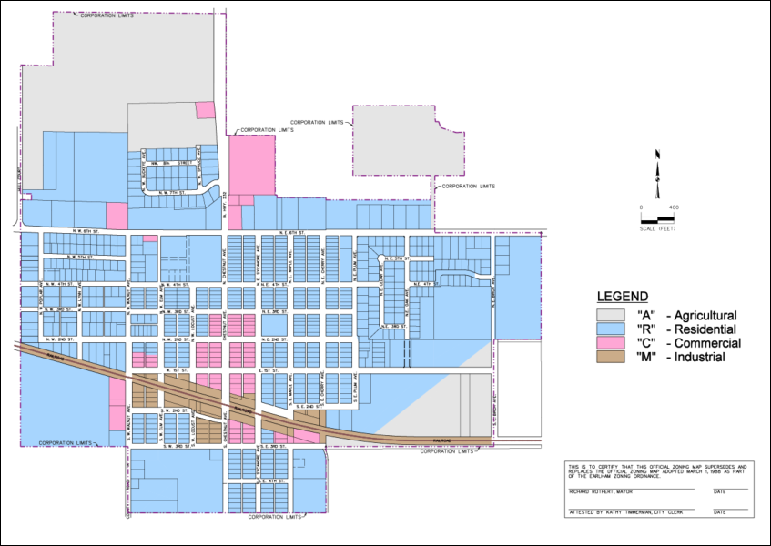
EXHIBIT B

ASSESSED VALUATIONS OF LAND AND BUILDINGS AND OWNERS OF RECORD OF REAL ESTATE

A list of the totals of the existing valuations of the real estate in the Area, listing the land and building values separately is set forth below:

Number of Parcels | Assessed Value of Land | Assessed Value of Commercial and Industrial Buildings | Assessed Value of Residential Buildings
652 | $12,409,400 | $9,416,536 | $61,736,300

Existing assessed values for land and buildings within the Area and the names and addresses of the owners of record of the real estate within the Area are compiled on spreadsheets, located at the Clerk’s Office at City Hall. Accommodations for viewing will be made.

