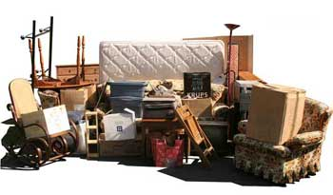

Earlham City Wide
Clean-Up
June 17, 2023

All items must be placed street side
by 7:00 AM (NO alley pick up).

List of Acceptable and Non-Acceptable Items
can be found on here
List is also available at City Hall

Contact Earlham City Hall at 758-2281
if you have questions.

